 

# Lecture-3 Computer Network Models

# Computer Network Models

A communication subsystem is a complex piece of Hardware and software. Early attempts for implementing the software for such subsystems were based on a single, complex, unstructured program with many interacting components. The resultant software was very difficult to test and modify. To overcome such problem, the ISO has developed a layered approach. In a layered approach, networking concept is divided into several layers, and each layer is assigned a particular task. Therefore, we can say that networking tasks depend upon the layers.

## Layered Architecture

* The main aim of the layered architecture is to divide the design into small pieces.
* Each lower layer adds its services to the higher layer to provide a full set of services to manage communications and run the applications.
* It provides modularity and clear interfaces, i.e., provides interaction between subsystems.
* It ensures the independence between layers by providing the services from lower to higher layer without defining how the services are implemented. Therefore, any modification in a layer will not affect the other layers.
* The number of layers, functions, contents of each layer will vary from network to network. However, the purpose of each layer is to provide the service from lower to a higher layer and hiding the details from the layers of how the services are implemented.
* The basic elements of layered architecture are services, protocols, and interfaces.
  + **Service:** It is a set of actions that a layer provides to the higher layer.
  + **Protocol:** It defines a set of rules that a layer uses to exchange the information with peer entity. These rules mainly concern about both the contents and order of the messages used.
  + **Interface:** It is a way through which the message is transferred from one layer to another layer.
* In a layer n architecture, layer n on one machine will have a communication with the layer n on another machine and the rules used in a conversation are known as a layer-n protocol.

**Let's take an example of the five-layered architecture.**

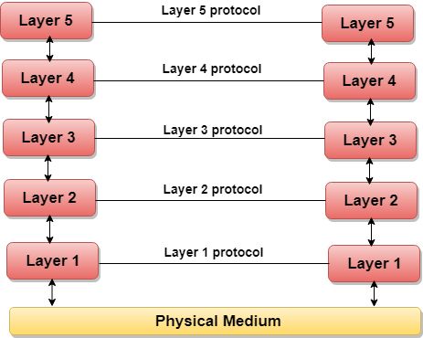

## Why do we require Layered architecture?

* **Divide-and-conquer approach:** Divide-and-conquer approach makes a design process in such a way that the unmanageable tasks are divided into small and manageable tasks. In short, we can say that this approach reduces the complexity of the design.
* **Modularity:** Layered architecture is more modular. Modularity provides the independence of layers, which is easier to understand and implement.
* **Easy to modify:** It ensures the independence of layers so that implementation in one layer can be changed without affecting other layers.
* **Easy to test:** Each layer of the layered architecture can be analyzed and tested individually.

# OSI Model

* OSI stands for **Open System Interconnection** is a reference model that describes how information from a software application in one computer moves through a physical medium to the software application in another computer.
* OSI consists of seven layers, and each layer performs a particular network function.
* OSI model was developed by the International Organization for Standardization (ISO) in 1984, and it is now considered as an architectural model for the inter-computer communications.
* OSI model divides the whole task into seven smaller and manageable tasks. Each layer is assigned a particular task.
* Each layer is self-contained, so that task assigned to each layer can be performed independently.

## Characteristics of OSI Model:

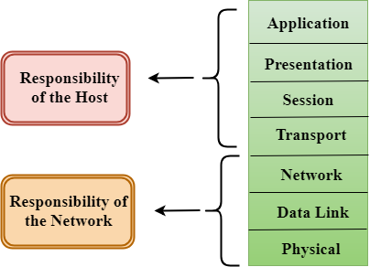

* The OSI model is divided into two layers: upper layers and lower layers.
* The upper layer of the OSI model mainly deals with the application related issues, and they are implemented only in the software. The application layer is closest to the end user. Both the end user and the application layer interact with the software applications. An upper layer refers to the layer just above another layer.
* The lower layer of the OSI model deals with the data transport issues. The data link layer and the physical layer are implemented in hardware and software. The physical layer is the lowest layer of the OSI model and is closest to the physical medium. The physical layer is mainly responsible for placing the information on the physical medium.

## Functions of the OSI Layers

There are the seven OSI layers. Each layer has different functions. A list of seven layers are given below:

1. Physical Layer
2. Data-Link Layer
3. Network Layer
4. Transport Layer
5. Session Layer
6. Presentation Layer
7. Application Layer

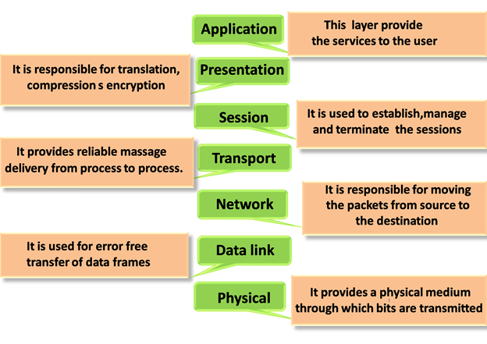

### Physical layer

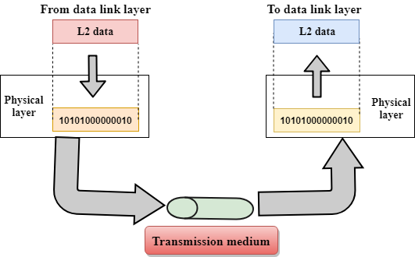

* The main functionality of the physical layer is to transmit the individual bits from one node to another node.
* It is the lowest layer of the OSI model.
* It establishes, maintains and deactivates the physical connection.
* It specifies the mechanical, electrical and procedural network interface specifications.

## Functions of a Physical layer:

* **Line Configuration:** It defines the way how two or more devices can be connected physically.
* [**Data Transmission**](https://www.javatpoint.com/computer-network-transmission-modes)**:** It defines the transmission mode whether it is simplex, half-duplex or full-duplex mode between the two devices on the network.
* [**Topology**](https://www.javatpoint.com/computer-network-topologies)**:** It defines the way how network devices are arranged.
* **Signals:** It determines the type of the signal used for transmitting the information.

### Data-Link Layer

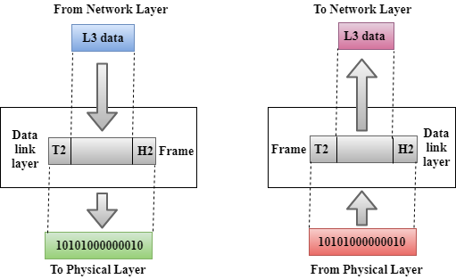

* This layer is responsible for the error-free transfer of data frames.
* It defines the format of the data on the network.
* It provides a reliable and efficient communication between two or more devices.
* It is mainly responsible for the unique identification of each device that resides on a local network.
* It contains two sub-layers:
  + **Logical Link Control Layer**
    - It is responsible for transferring the packets to the Network layer of the receiver that is receiving.
    - It identifies the address of the network layer protocol from the header.
    - It also provides flow control.
  + **Media Access Control Layer**
    - A Media access control layer is a link between the Logical Link Control layer and the network's physical layer.
    - It is used for transferring the packets over the network.

## Functions of the Data-link layer

* **Framing:** The data link layer translates the physical's raw bit stream into packets known as Frames. The Data link layer adds the header and trailer to the frame. The header which is added to the frame contains the hardware destination and source address.

OSI Model

* **Physical Addressing:** The Data link layer adds a header to the frame that contains a destination address. The frame is transmitted to the destination address mentioned in the header.
* **Flow Control:** Flow control is the main functionality of the Data-link layer. It is the technique through which the constant data rate is maintained on both the sides so that no data get corrupted. It ensures that the transmitting station such as a server with higher processing speed does not exceed the receiving station, with lower processing speed.
* **Error Control:** Error control is achieved by adding a calculated value CRC (Cyclic Redundancy Check) that is placed to the Data link layer's trailer which is added to the message frame before it is sent to the physical layer. If any error seems to occur, then the receiver sends the acknowledgment for the retransmission of the corrupted frames.
* **Access Control:** When two or more devices are connected to the same communication channel, then the data link layer protocols are used to determine which device has control over the link at a given time.

### Network Layer

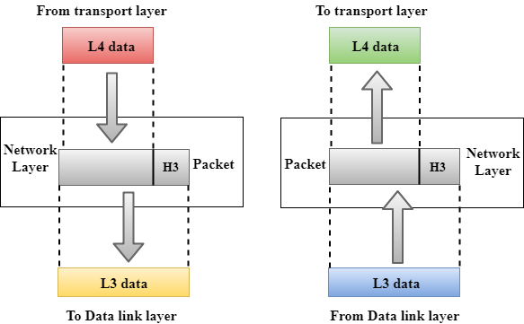

* It is a layer 3 that manages device addressing, tracks the location of devices on the network.
* It determines the best path to move data from source to the destination based on the network conditions, the priority of service, and other factors.
* The Network layer is responsible for routing and forwarding the packets.
* Routers are the layer 3 devices, they are specified in this layer and used to provide the routing services within an internetwork.
* The protocols used to route the network traffic are known as Network layer protocols. Examples of protocols are IPv4 and Ipv6.

## Functions of Network Layer:

* **Internetworking:** An internetworking is the main responsibility of the network layer. It provides a logical connection between different devices.
* [**Addressing**](https://www.javatpoint.com/network-addressing)**:** A Network layer adds the source and destination address to the header of the frame. Addressing is used to identify the device on the internet.
* [**Routing**](https://www.javatpoint.com/computer-network-routing)**:** Routing is the major component of the network layer, and it determines the best optimal path out of the multiple paths from source to the destination.
* **Packetizing:** A Network Layer receives the packets from the upper layer and converts them into packets. This process is known as Packetizing. It is achieved by internet protocol (IP).

### Transport Layer

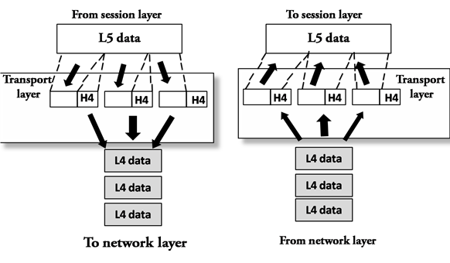

* The Transport layer is a Layer 4 ensures that messages are transmitted in the order in which they are sent and there is no duplication of data.
* The main responsibility of the transport layer is to transfer the data completely.
* It receives the data from the upper layer and converts them into smaller units known as segments.
* This layer can be termed as an end-to-end layer as it provides a point-to-point connection between source and destination to deliver the data reliably.

**The two protocols used in this layer are:**

* **Transmission Control Protocol**
  + It is a standard protocol that allows the systems to communicate over the internet.
  + It establishes and maintains a connection between hosts.
  + When data is sent over the TCP connection, then the TCP protocol divides the data into smaller units known as segments. Each segment travels over the internet using multiple routes, and they arrive in different orders at the destination. The transmission control protocol reorders the packets in the correct order at the receiving end.
* **User Datagram Protocol**
  + User Datagram Protocol is a transport layer protocol.
  + It is an unreliable transport protocol as in this case receiver does not send any acknowledgment when the packet is received, the sender does not wait for any acknowledgment. Therefore, this makes a protocol unreliable.

## Functions of Transport Layer:

* **Service-point addressing:** Computers run several programs simultaneously due to this reason, the transmission of data from source to the destination not only from one computer to another computer but also from one process to another process. The transport layer adds the header that contains the address known as a service-point address or port address. The responsibility of the network layer is to transmit the data from one computer to another computer and the responsibility of the transport layer is to transmit the message to the correct process.
* **Segmentation and reassembly:** When the transport layer receives the message from the upper layer, it divides the message into multiple segments, and each segment is assigned with a sequence number that uniquely identifies each segment. When the message has arrived at the destination, then the transport layer reassembles the message based on their sequence numbers.
* **Connection control:** Transport layer provides two services Connection-oriented service and connectionless service. A connectionless service treats each segment as an individual packet, and they all travel in different routes to reach the destination. A connection-oriented service makes a connection with the transport layer at the destination machine before delivering the packets. In connection-oriented service, all the packets travel in the single route.
* **Flow control:** The transport layer also responsible for flow control but it is performed end-to-end rather than across a single link.
* **Error control:** The transport layer is also responsible for Error control. Error control is performed end-to-end rather than across the single link. The sender transport layer ensures that message reach at the destination without any error.

### Session Layer

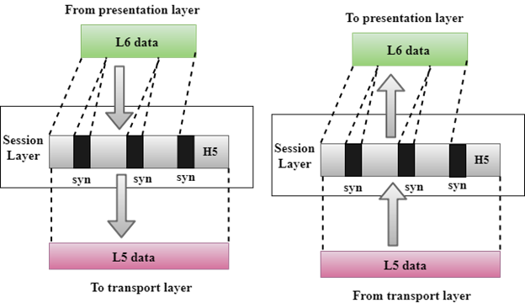

* It is a layer 5 in the OSI model.
* The Session layer is used to establish, maintain and synchronizes the interaction between communicating devices.

## Functions of Session layer:

* **Dialog control:** Session layer acts as a dialog controller that creates a dialog between two processes or we can say that it allows the communication between two processes which can be either half-duplex or full-duplex.
* **Synchronization:** Session layer adds some checkpoints when transmitting the data in a sequence. If some error occurs in the middle of the transmission of data, then the transmission will take place again from the checkpoint. This process is known as Synchronization and recovery.

### Presentation Layer

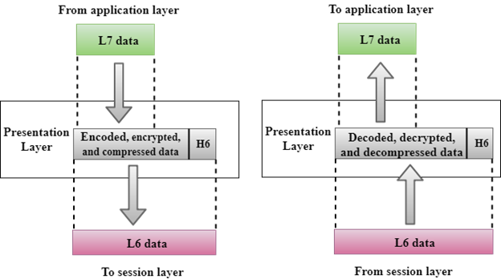

* A Presentation layer is mainly concerned with the syntax and semantics of the information exchanged between the two systems.
* It acts as a data translator for a network.
* This layer is a part of the operating system that converts the data from one presentation format to another format.
* The Presentation layer is also known as the syntax layer.

## Functions of Presentation layer:

* **Translation:** The processes in two systems exchange the information in the form of character strings, numbers and so on. Different computers use different encoding methods, the presentation layer handles the interoperability between the different encoding methods. It converts the data from sender-dependent format into a common format and changes the common format into receiver-dependent format at the receiving end.
* **Encryption:** Encryption is needed to maintain privacy. Encryption is a process of converting the sender-transmitted information into another form and sends the resulting message over the network.
* **Compression:** Data compression is a process of compressing the data, i.e., it reduces the number of bits to be transmitted. Data compression is very important in multimedia such as text, audio, video.

### Application Layer

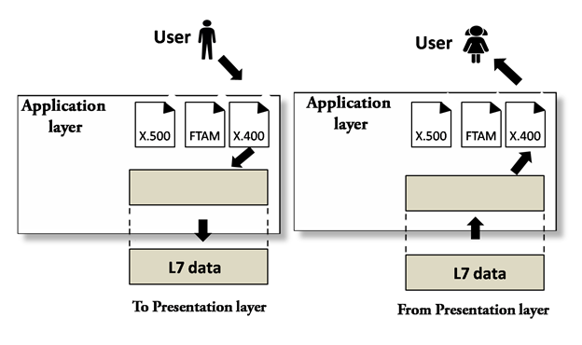

* An application layer serves as a window for users and application processes to access network service.
* It handles issues such as network transparency, resource allocation, etc.
* An application layer is not an application, but it performs the application layer functions.
* This layer provides the network services to the end-users.

## Functions of Application layer:

* **File transfer, access, and management (FTAM):** An application layer allows a user to access the files in a remote computer, to retrieve the files from a computer and to manage the files in a remote computer.
* **Mail services:** An application layer provides the facility for email forwarding and storage.
* Directory services: An application provides the distributed database sources and is used to provide that global information about various objects.

# TCP/IP Protocol Suite

* The TCP/IP protocol suite was developed prior to the OSI model.
* The TCP/IP protocol suite is not exactly similar to the OSI model.
* The TCP/IP protocol suite consists of five layers: the application layer, transport layer, internet layer or network access layer, data link, physical layer.
* The first four layers provide physical standards, network interface, internetworking, and transport functions that correspond to the first four layers of the OSI model and these four layers are represented in TCP/IP model by a single layer called the application layer.
* TCP/IP is a hierarchical protocol made up of interactive modules, and each of them provides specific functionality.

Here, hierarchical means that each upper-layer protocol is supported by two or more lower-level protocols.

## TCP/IP and OSI Model:

